ACTIVITY 1.35

**Q1. 1) Write a python program to solve the following requirements.  
a. Read unsorted ‘n’ integers using input () and store them in a list (say list_numbers). Minimum size of the list_numbers should be 10.  
b. Print the list_numbers on the screen.  
c. Read a number (say number_to_be_searched) using input().  
d. Perform ‘linear search’ to find whether the number_to_be_searched is present or not in list_numbers.  
e. Print the suitable result  
 i. The searched element (print the actual value) is PRESENT in list_number.  
 (or)  
 ii. The searched element (print the actual value) is NOT PRESENT in list_number.  
f. Count the number of comparisons and print it.  
g. Run the same program for different number_to_be_searched and record the outputs.**

**#code screenshot**

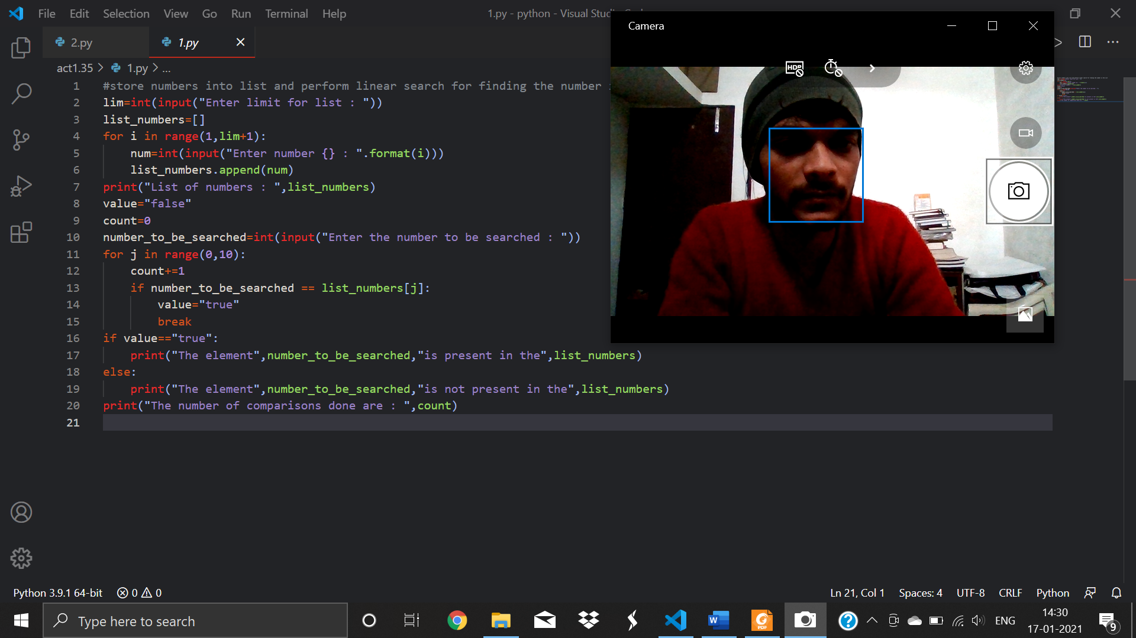

**#code**

#store numbers into list and perform linear search for finding the number in the list

lim=int(input("Enter limit for list : "))

list_numbers=[]

for i in range(1,lim+1):

    num=int(input("Enter number {} : ".format(i)))

    list_numbers.append(num)

print("List of numbers : ",list_numbers)

value="false"

count=0

number_to_be_searched=int(input("Enter the number to be searched : "))

for j in range(0,10):

    count+=1

    if number_to_be_searched == list_numbers[j]:

        value="true"

        break

if value=="true":

    print("The element",number_to_be_searched,"is present in the",list_numbers)

else:

    print("The element",number_to_be_searched,"is not present in the",list_numbers)

print("The number of comparisons done are : ",count)

**#output screenshot 1**

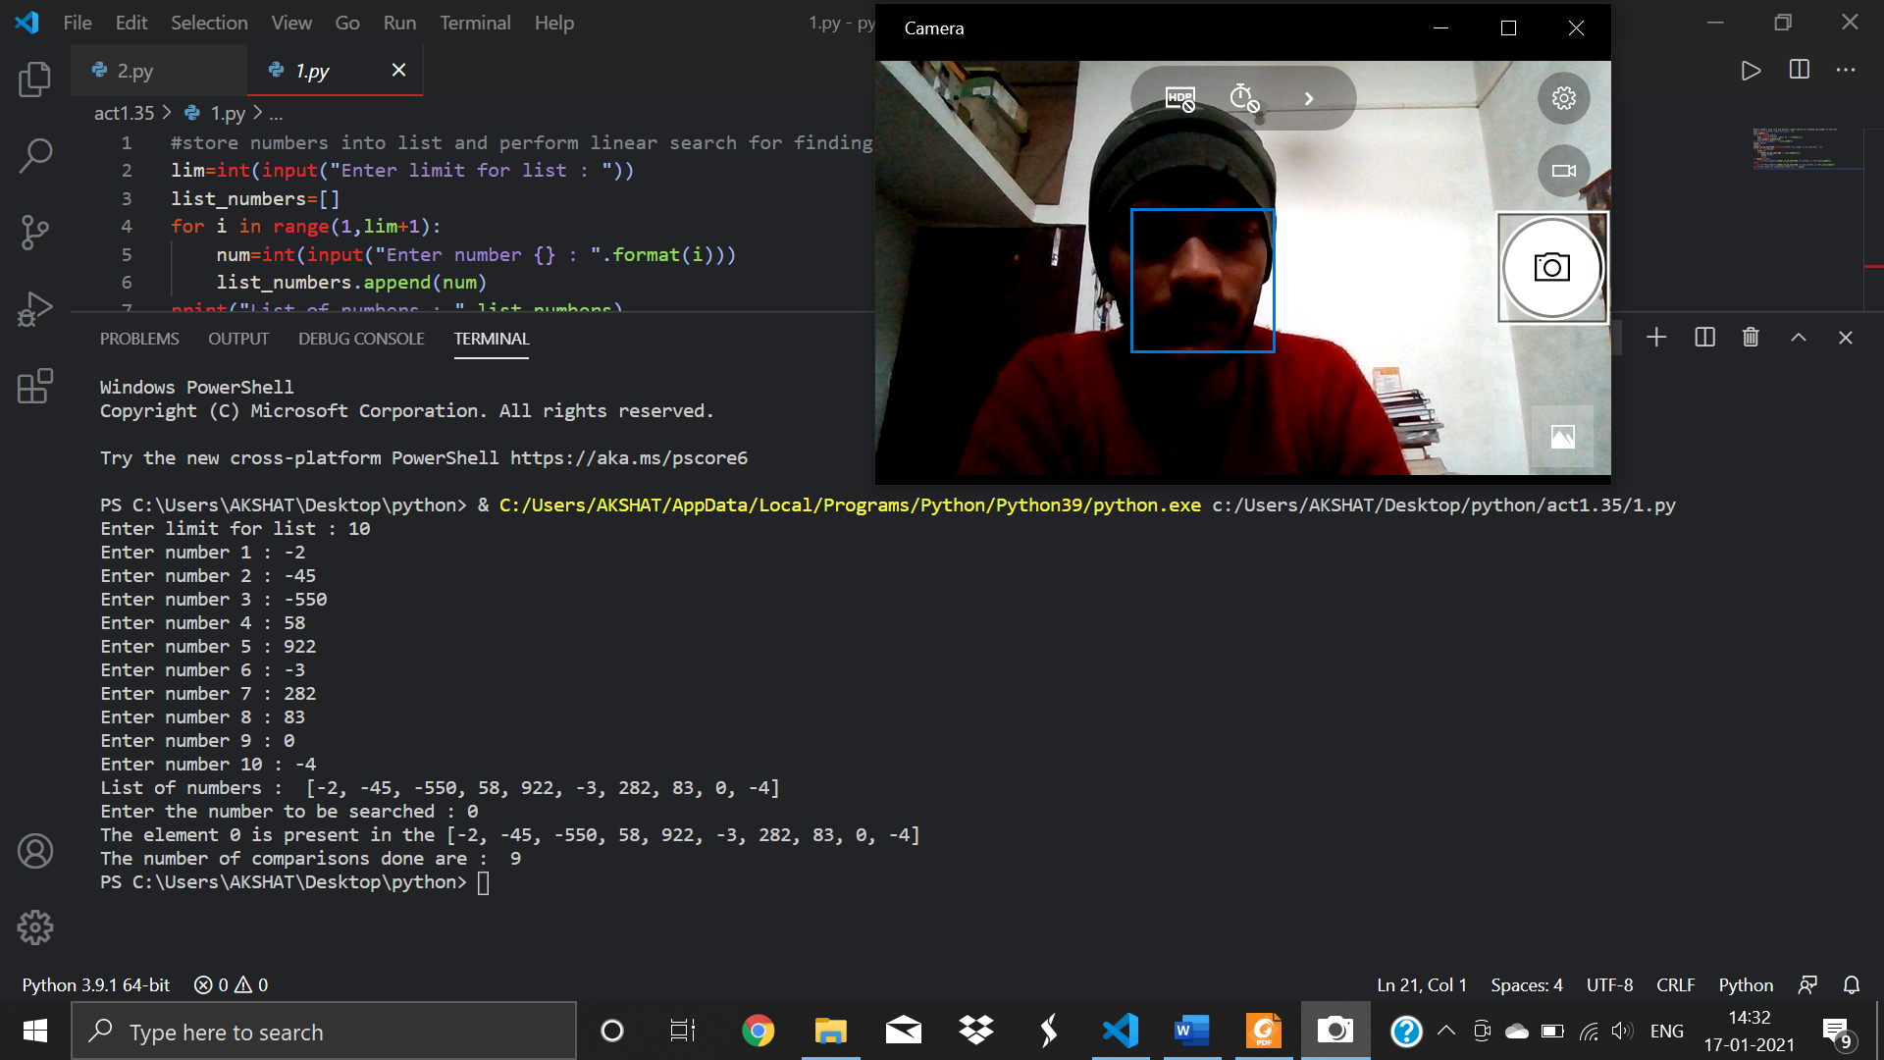

**#output screenshot 2**

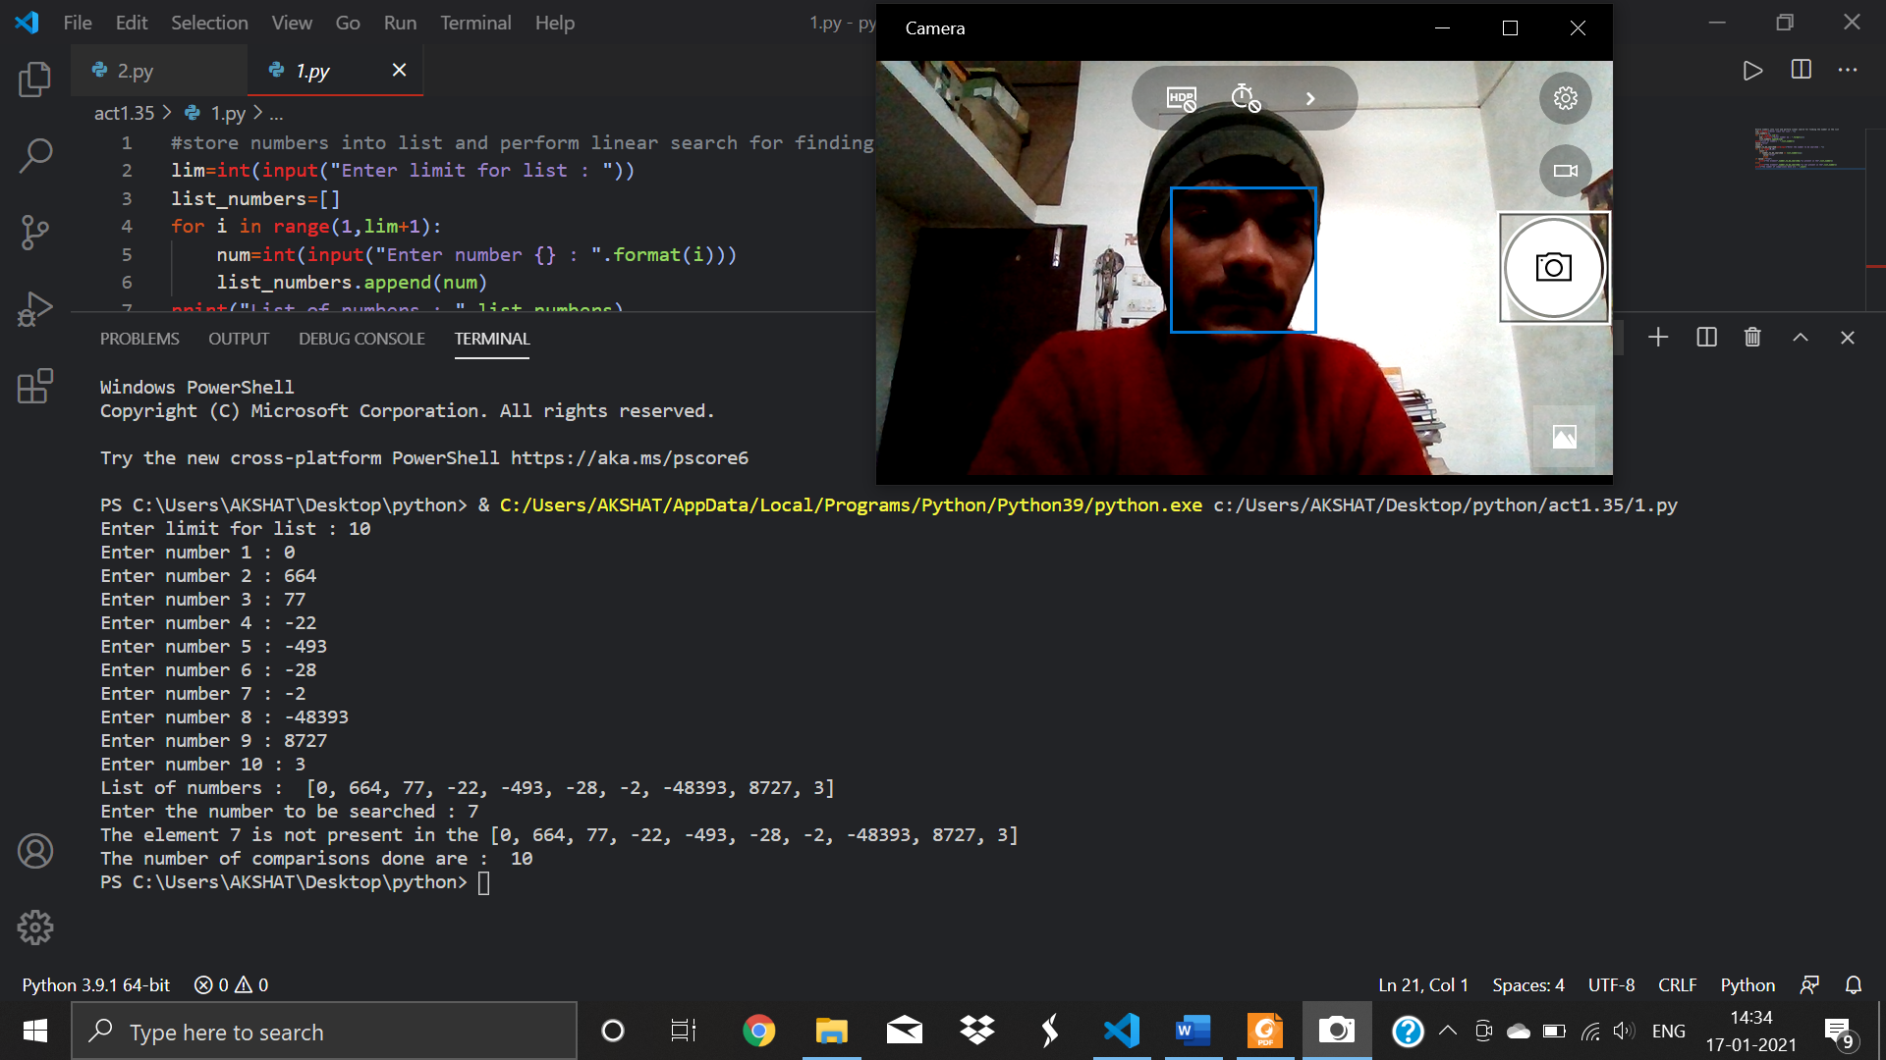

**Q2. Write a python program to solve the following requirements.**

**a. Read sorted ‘n’ integers using input () and store them in a list (say list_numbers). Minimum size of the list_numbers should be 10.  
b. Print the list_numbers on the screen.  
c. Read a number (say number_to_be_searched) using input().  
d. Perform ‘binary search’ to find whether the number_to_be_searched is present or not in list_numbers.  
e. Print the suitable result**

**#code screenshot**

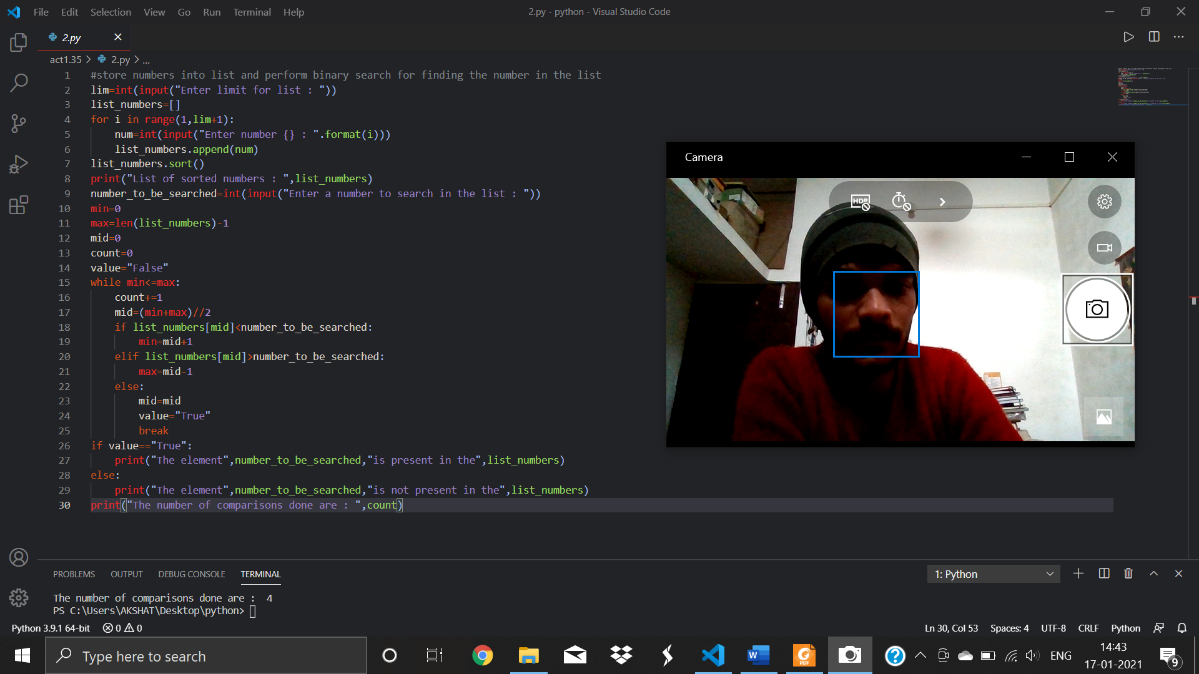

**#code**

#store numbers into list and perform binary search for finding the number in the list

lim=int(input("Enter limit for list : "))

list_numbers=[]

for i in range(1,lim+1):

    num=int(input("Enter number {} : ".format(i)))

    list_numbers.append(num)

list_numbers.sort()

print("List of sorted numbers : ",list_numbers)

number_to_be_searched=int(input("Enter a number to search in the list : "))

min=0

max=len(list_numbers)-1

mid=0

count=0

value="False"

while min<=max:

    count+=1

    mid=(min+max)//2

    if list_numbers[mid]<number_to_be_searched:

        min=mid+1

    elif list_numbers[mid]>number_to_be_searched:

        max=mid-1

    else:

        mid=mid

        value="True"

        break

if value=="True":

    print("The element",number_to_be_searched,"is present in the",list_numbers)

else:

    print("The element",number_to_be_searched,"is not present in the",list_numbers)

print("The number of comparisons done are : ",count)

**#output screenshot**

